Pins & String

In 1846, James Clerk Maxwell (then14 years old, later a famous physicist), published *Propositions on Oval Curves*, which explains how to draw ovals using a single piece of string and various numbers of pins.

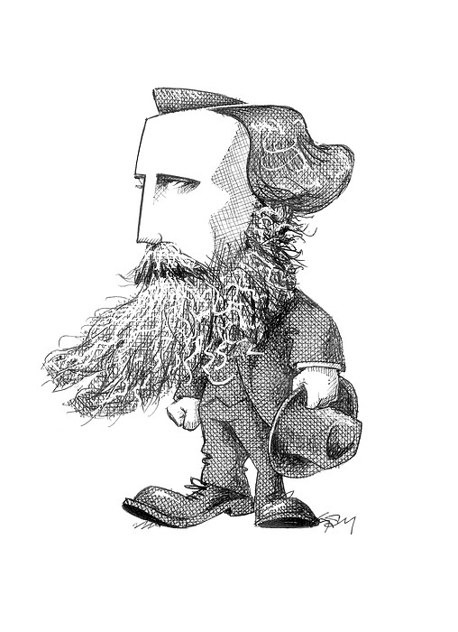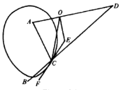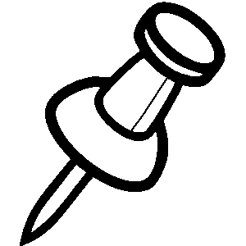

Task: Two Pins

Draw as many different kinds of ovals you can with a single piece of string and TWO pins. Record your observations below.

Task: Three Pins

Draw as many different kinds of ovals you can with a single piece of string and THREE pins. Record your observations below.

Task: $n$ Pins

Draw as many different kinds of ovals you can with a single piece of string and four or more pins. Record your observations below.